Change Log

1-30-20

We finally received the parts and were able to start working on the project.

Today we installed the software on the PC and on the SD card. We also configured the wireless router and unboxed the car. We are still waiting on the kit to attach the pi to the car

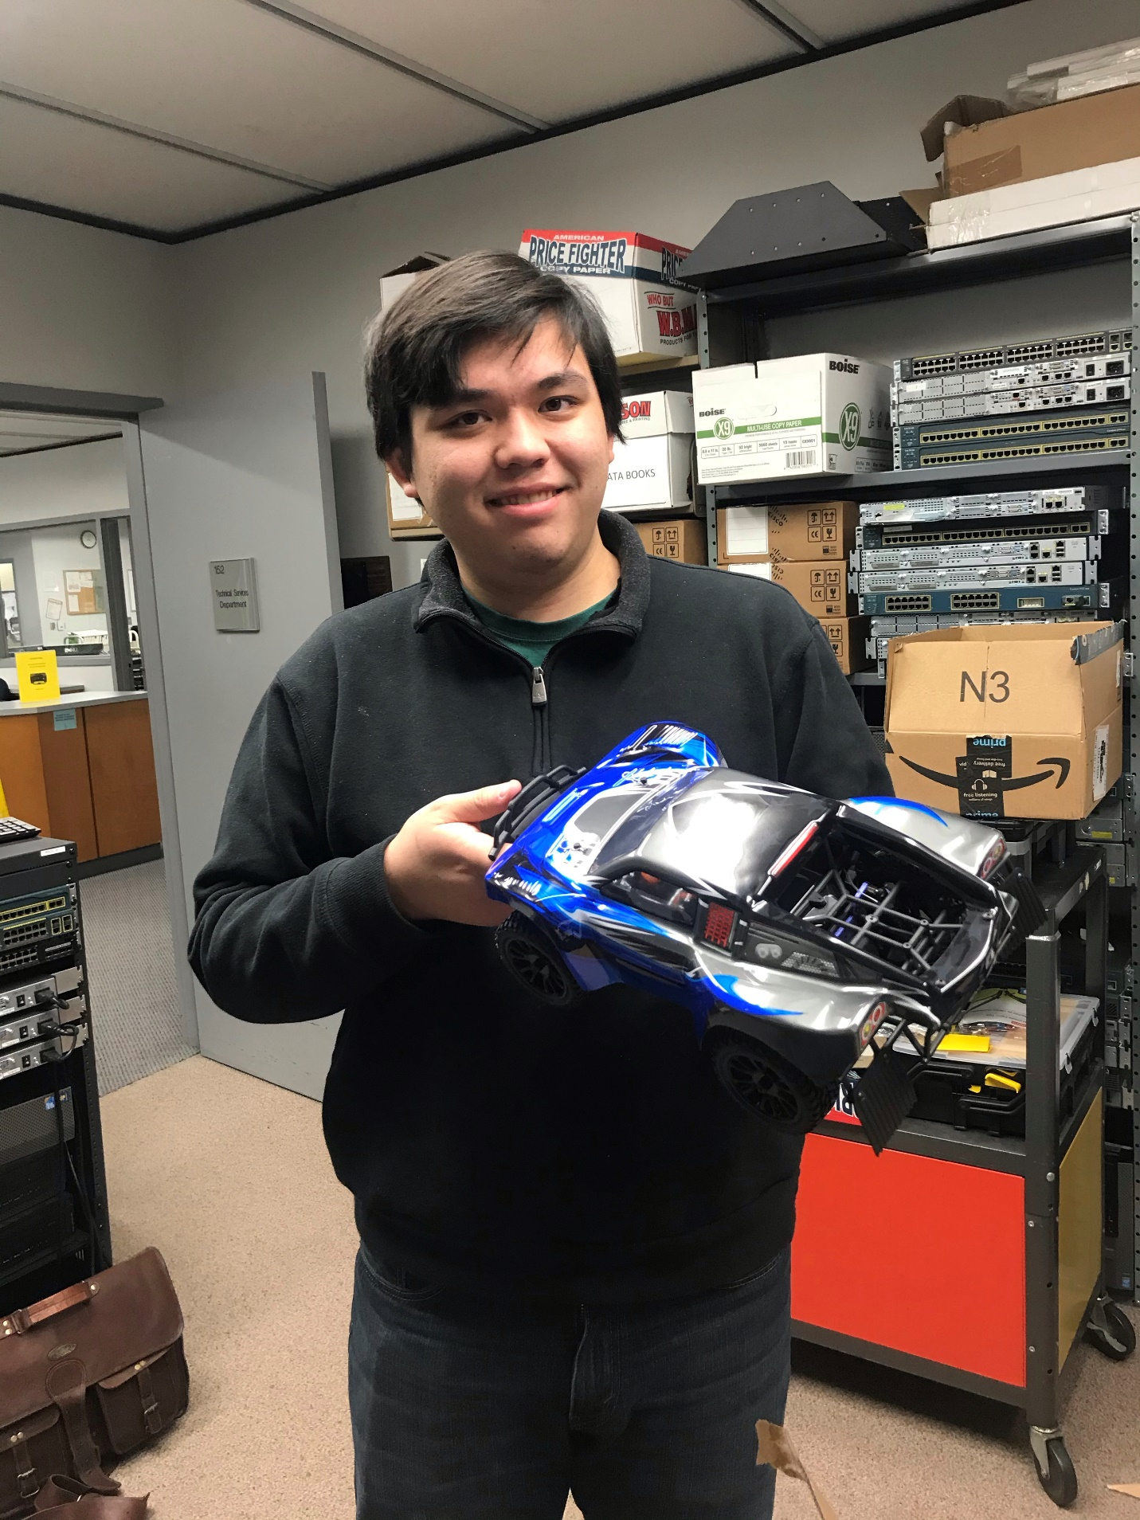

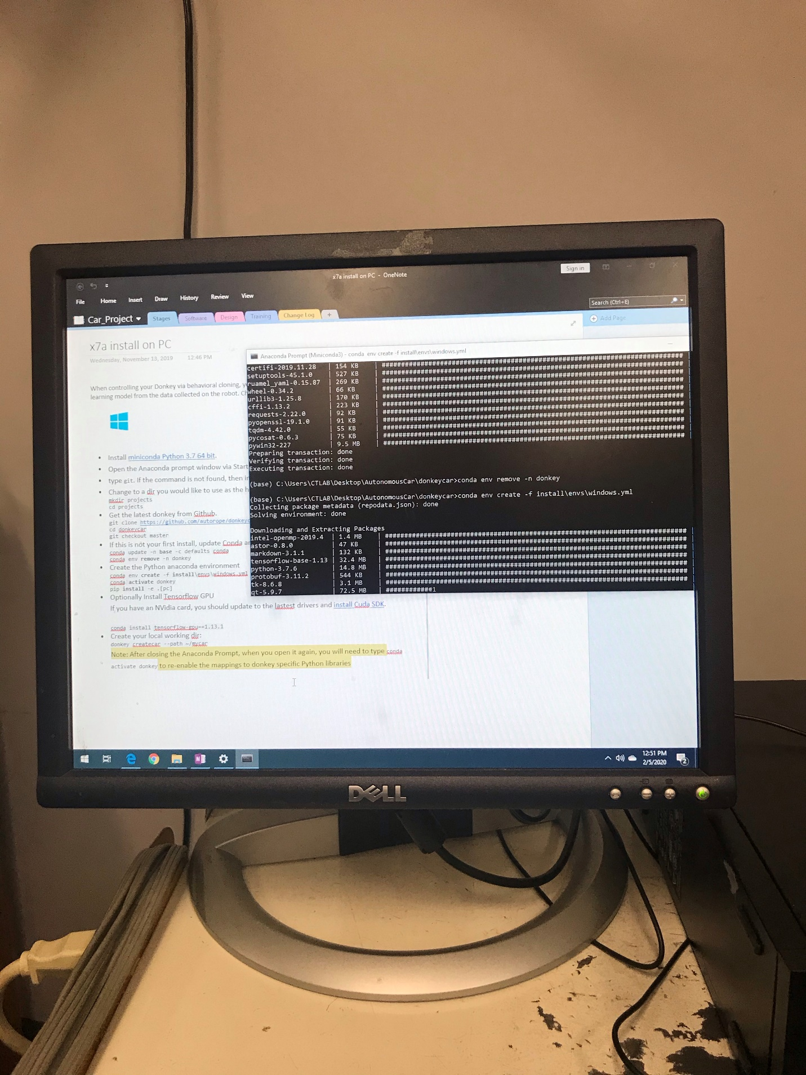

2-6-20

We started attaching the circuit boards

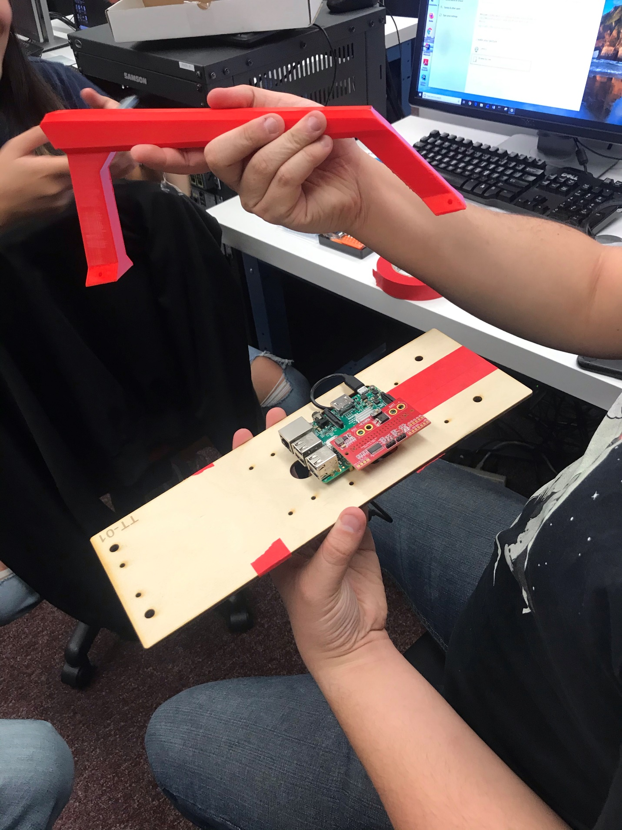

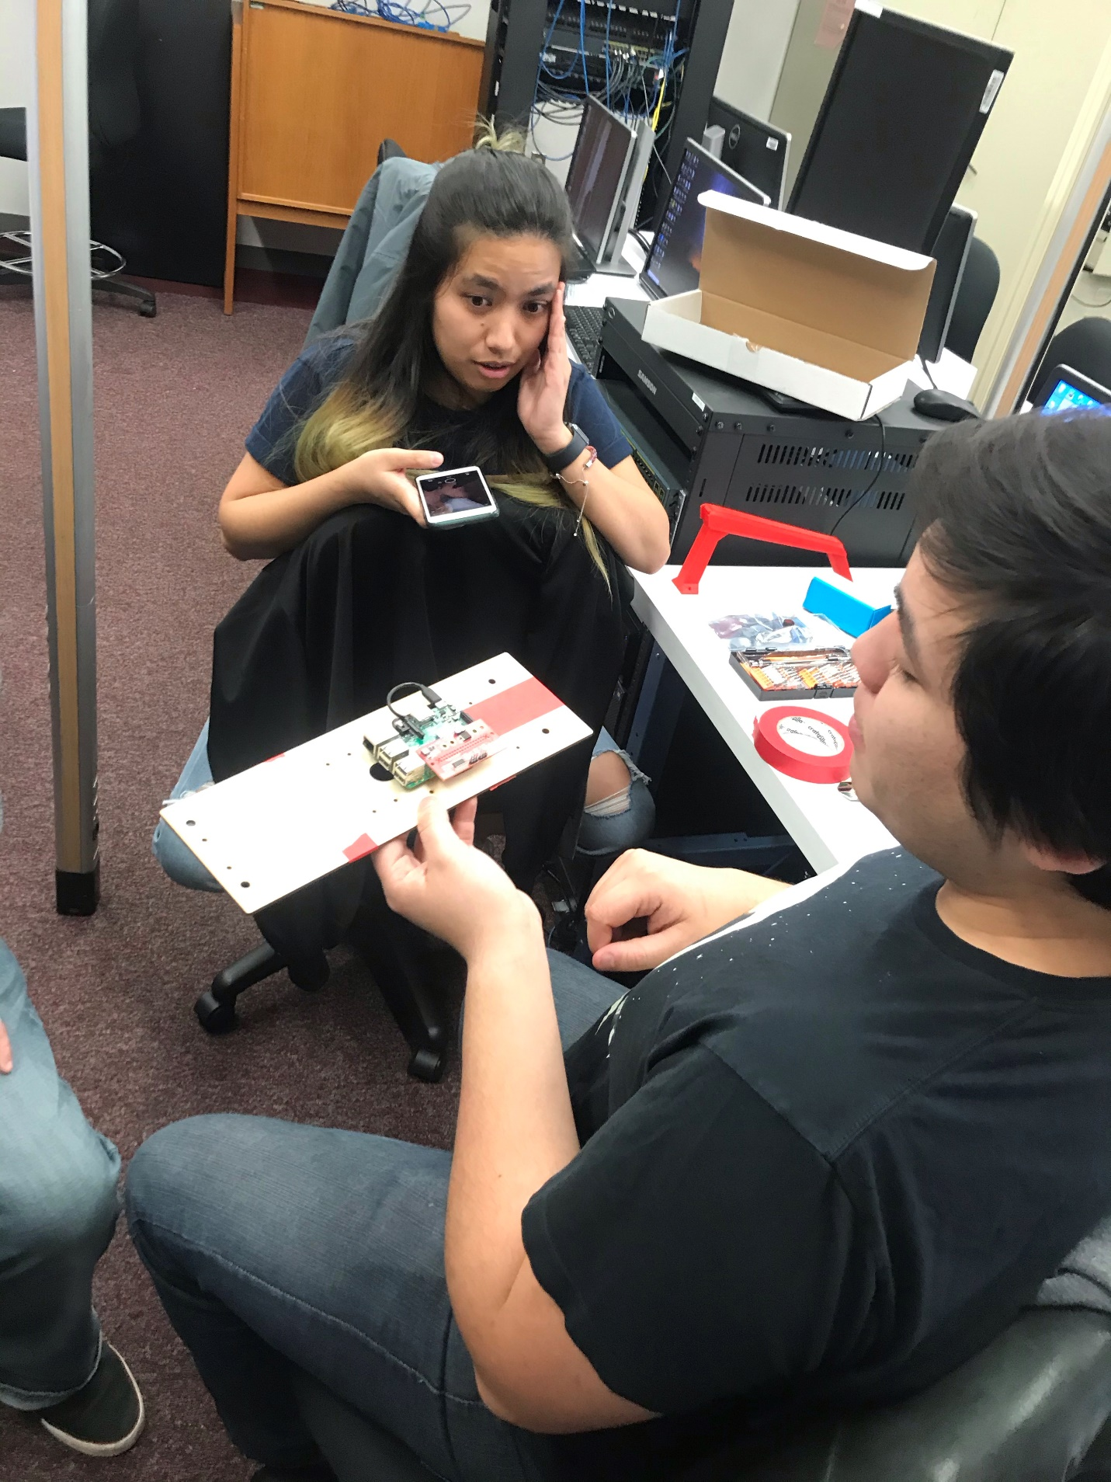

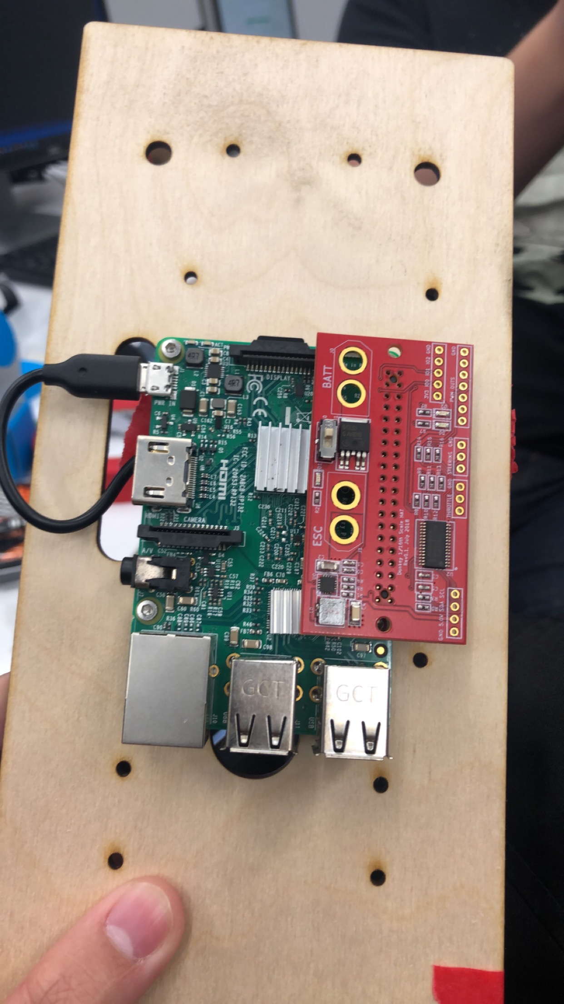

2-6-20

There is a software simulator where we can train the "driver" without actually having to drive the physical car around a track.

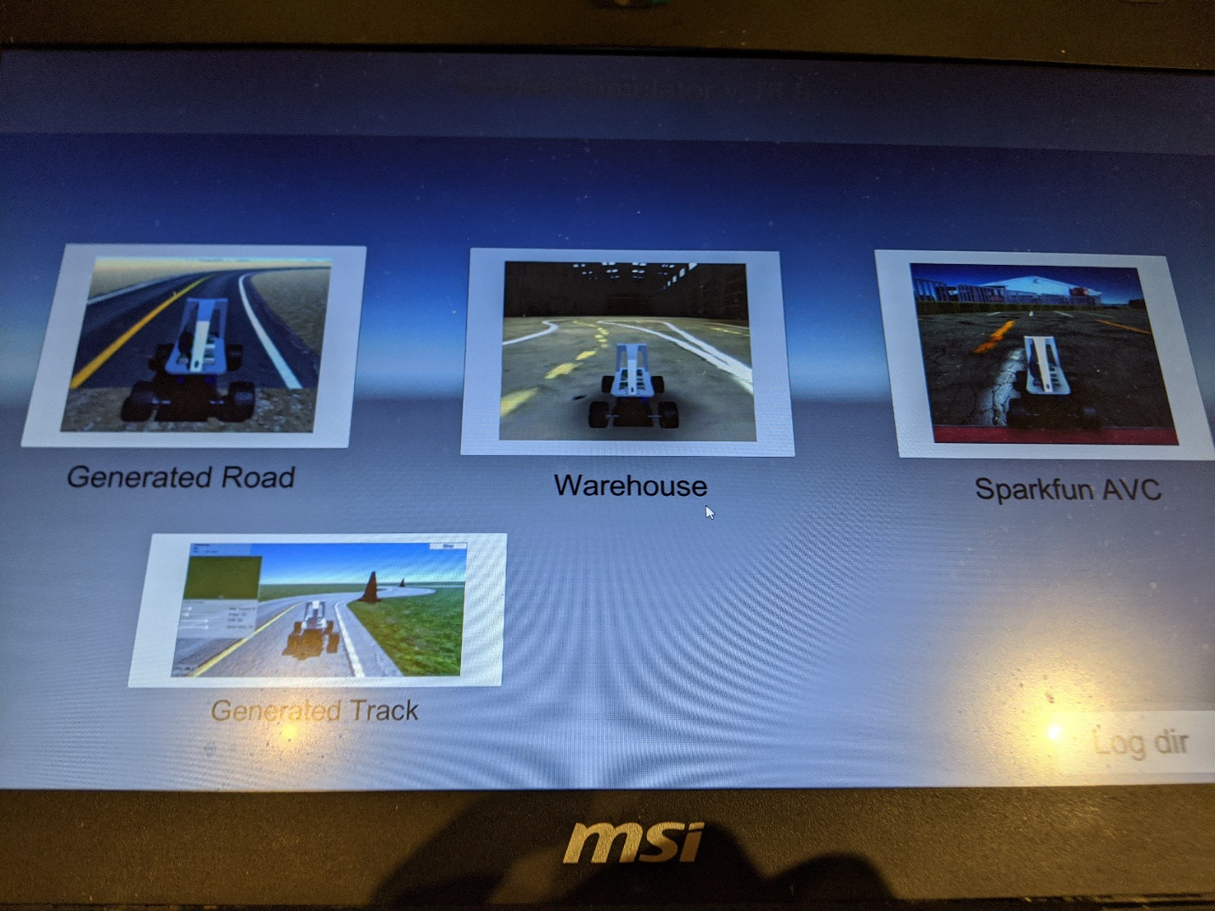

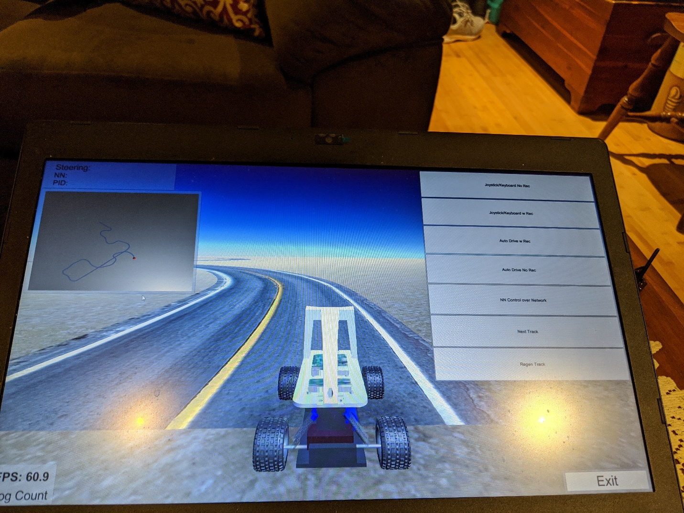

2-14-20

Mark loaded the Raspberry lite OS onto the Micro SD card, Domenico then in the Raspberry OS added the file SSH to the boot directory to allow ssh connections.

Bethany then took over connecting the Pi to our network. The initial configurations were not working so she made a few changes to the network configurations on the Pi. This however was unsuccessful.

Then Bethany and Domenico changed the interfaces file to create a static IP address. After doing so we discovered that in Raspberian that is not how you should set a static IP. We needed to make changes to the dhcpcp.conf file, so that's what we did next to try to gain network access. That didn't completely work, so we whent to Frank and asked for help. Hee was able to offer some good advice about looking at the script for the boot process.

After working on the problem of configuring the Pi to connect to the wireless router on boot for about 6 hours, we were still unsuccessful so Bethany took the Pi home to work on it over the weekend.

Edit: To connect to the network, we edited the wpa_suplicant to match up to the network we created.

After editing the wpa_suplicant, we have to make sure that it will run during start up. Under /etc/network/interfaces.d

auto wlan0

iface wlan0 inet static

address 192.168.1.10

netmask 255.255.255.0

gateway 192.168.1.1

dns-nameservers 1.1.1.1

allow-hotplug wlan0

iface wlan0 inet manual

wpa_conf /etc/wpa_supplicant/wpa_supplicant.conf

2-14-20

Charlie was able to attach the base board to the car chassis and connect the cable to control the throttle and steering to channels 3 and 4 respectively.

Channels

Throttle: 3

Steering: 4

2-21-20

We have managed to get the car to connect to the wireless network on boot. We then started going through the steps in Stage 7b.

Edit: Instead of installing pip install tensorflow==1.13.1 We installed 1.14.0.

2-25-20

Mark took the car and router home with him to see how the software on the PC interacts with the software on the Car

2-27-20

We had been trying and failing to get the pi to connect over ssh on the wireless connection. Dom and Charlie discovered that it was the shield preventing the Pi from connecting. The shield was installed upside-down. After correcting the problem, we are now continuing with stage 7c, installing the AI onto the Pi. And Dom was able to install the build without issues.

The OS was complaining that the default username and password had not been changed, so I changed the login to:

Username: pi

Password: Password01

For the hardware

Charlie reinstalled the hardware correctly, and dry fit the pieces in advance of soldering.

Midway through downloading the project files onto the car, the router quit working. Apon rebooting the router and attempting to log back in we discovered that the password was not "Password01". So we ended the day and will reset the password tomorrow.

Update:

The password was correct, I (Dom) was just entering the user name wrong. I was entering Pi instead of pi

2-28-20

Today Charlie is soldering the circuitry together to make a permanent connection.

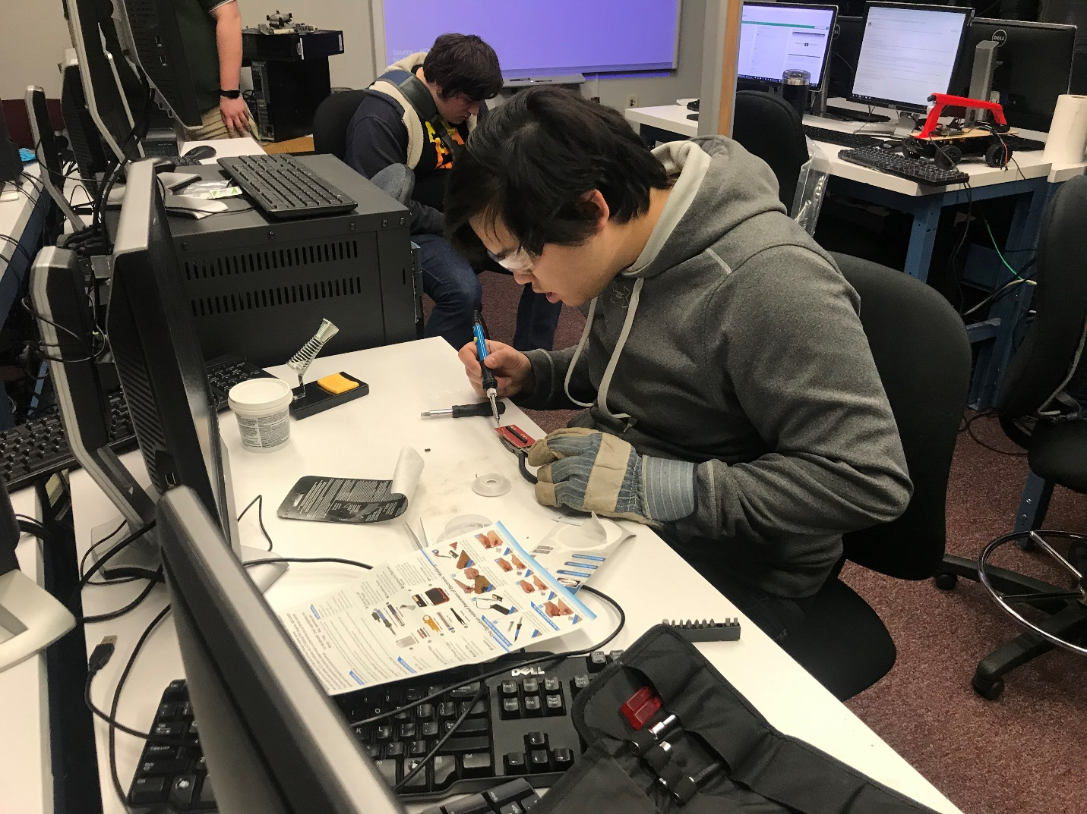

3-2-20

<<turning_wheels.MOV>>

Beth was able to get the Donkeycar project running on the pi by reinstalling the software from scratch. She was able to get the car to move forward and backwards and turn, but she is still unable to controle it through the web interface.

3-6-30

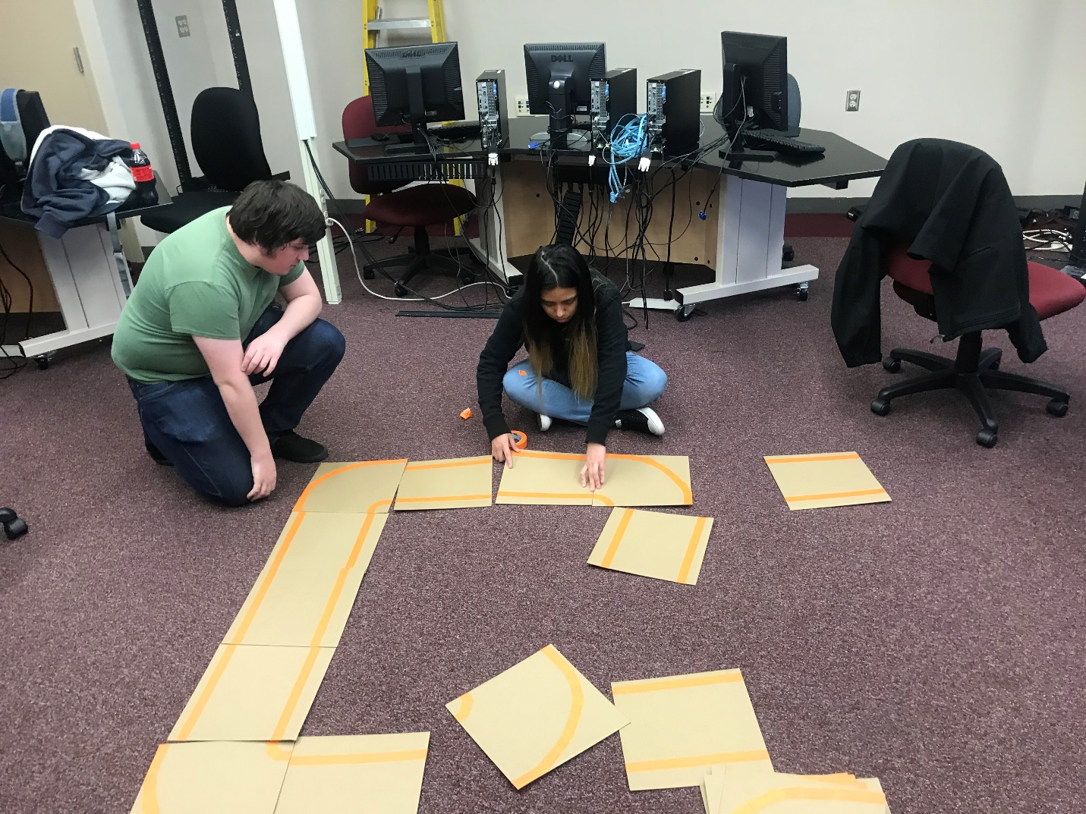

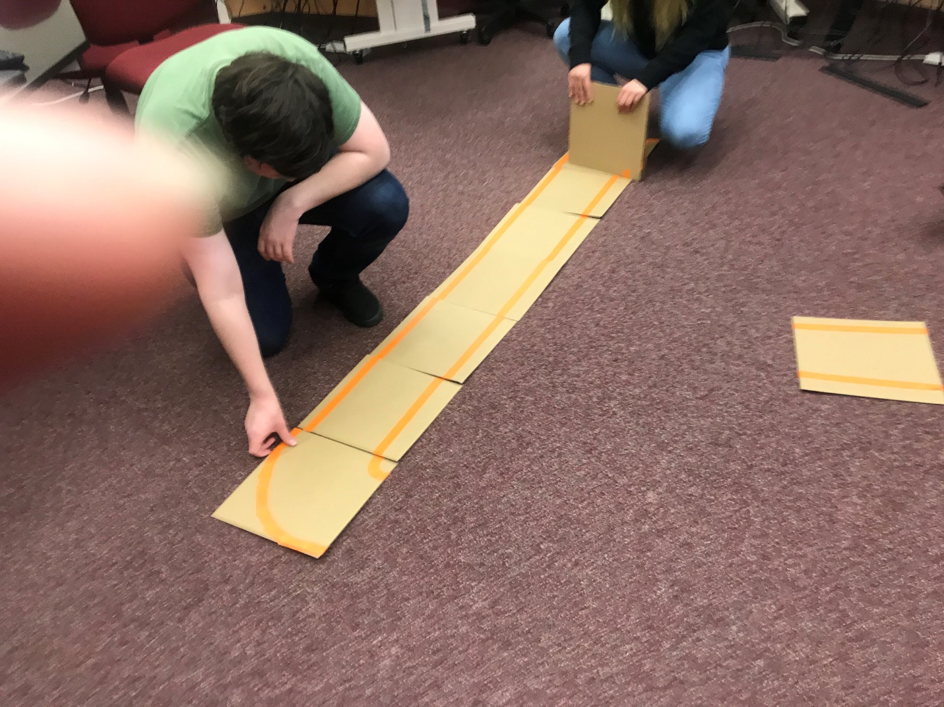

We started building the track for the car